**GSTR1 and GSTR3B Data Extraction Tool – User Manual**

# GSTR PDF Extractor Tool - User Manual Overview

The GSTR PDF Extractor is a sophisticated web-based application designed to

streamline the extraction and analysis of data from GSTR-1 and GSTR-3B return PDFs. This tool automates the retrieval of critical information from GST returns, minimizing manual data entry and allowing for batch processing of multiple documents

simultaneously. The application significantly enhances efficiency in GST data management by providing organized output in user-friendly formats with powerful filtering capabilities.

# Features

1. **GST Return Type Selection**

The tool supports two primary GST return types:

* + **GSTR-1**: Extracts outward supply details including total liability, B2B regular invoices (Table 4A), and B2B reverse charge invoices (Table 4B).
  + **GSTR-3B**: Extracts comprehensive data including general details, outward supplies, eligible ITC, and payment information.

# File Upload and Processing

* + **Multiple file uploads**: Supports batch processing of numerous PDF files simultaneously.
  + **Automated Data Extraction**: Efficiently extracts both metadata and tabular data from structured GST returns.

# Data Extraction GSTR-1 Returns:

* + Extracts key metadata: GSTIN, State, Legal Name, Month, Financial Year.
  + Processes Total Liability information (Outward supplies other than Reverse charge).
  + Extracts Table 4A data (Taxable outward supplies made to registered persons).
  + Extracts Table 4B data (Taxable outward supplies made to registered persons attracting tax on reverse charge).

# GSTR-3B Returns:

* + Extracts general details including GSTIN, Legal Name, State, Filing Date, Period, Financial Year.
  + Processes Table 3.1 (Outward and Reverse Charge Supplies).
  + Extracts Table 4 data (Eligible ITC).
  + Processes Table 6.1 data (Payment of Tax).
  + Creates a consolidated view combining all extracted data in a systematic format.

# Advanced Filtering

* + Multi-select filters with "Select All" option for:
    - Month
    - State
    - GSTIN
    - Legal Name
    - Financial Year
  + Filter combinations for targeted data analysis

# Output Format

* + **Interactive Data Tables**: Displays extracted data in user-friendly tables within the application.
  + **Excel Export**: Enables users to download filtered data in Excel format with multiple organized sheets.

# Visual Elements

* + Professional branding with company logo in the sidebar.
  + Clear section headers and intuitive layout.
  + Responsive design for various screen sizes.

# Usage Instructions

1. **Application Access**
   * Launch the application through the provided web link
   * The application will open with a sidebar containing configuration options.

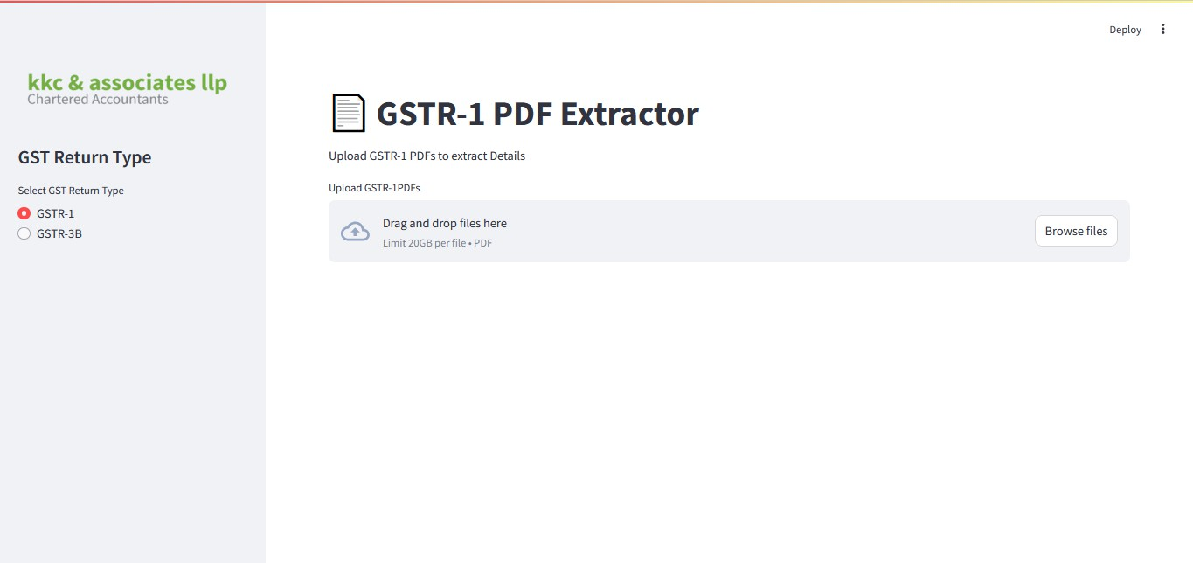

# Select GST Return Type

* + Choose either "GSTR-1" or "GSTR-3B" from the radio button options in the sidebar.
  + The main interface will update to reflect the selected return type.

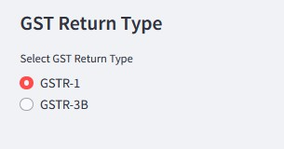

# Upload Files

* + Use the File Uploader in the main panel to select or drag-and-drop multiple PDF files.
  + The tool accepts standard PDF files generated from the GST portal.



# View Extracted Data

* + Once files are uploaded, the application automatically processes and displays the extracted data
  + For GSTR-1:
    - Total Liability information is shown in the first table
    - Table 4A (B2B Regular) data is displayed in a separate section
    - Table 4B (B2B Reverse charge) data is presented in another section

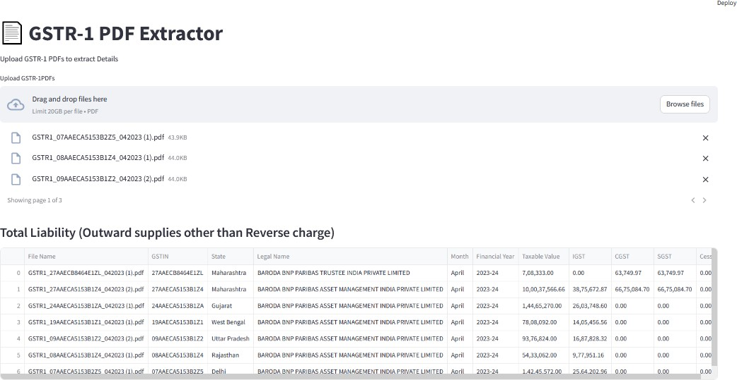

* + For GSTR-3B:
    - General Details are displayed first
    - Tables 3.1, 4, and 6.1 are shown in separate sections
    - A combined view presents all data in an organized format

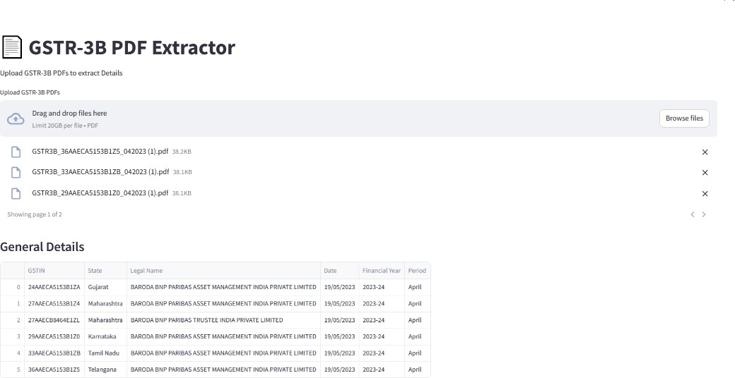

# Filter Data

* + Use the multi-select filter options to refine the displayed data:
    - Select specific months, states, GSTINs, legal names, or financial years.
    - Use "Select All" to include all options for a particular filter.
    - Multiple filters can be applied simultaneously for precise data selection.

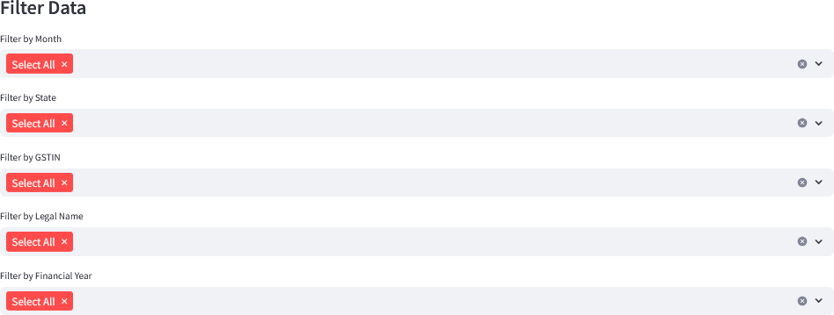

# Download Filtered Data

* + Click the "Download Filtered Data as Excel" button (for GSTR-1) or "Download Filtered Data" button (for GSTR-3B).
  + The Excel file will contain multiple sheets organizing the filtered data by category.

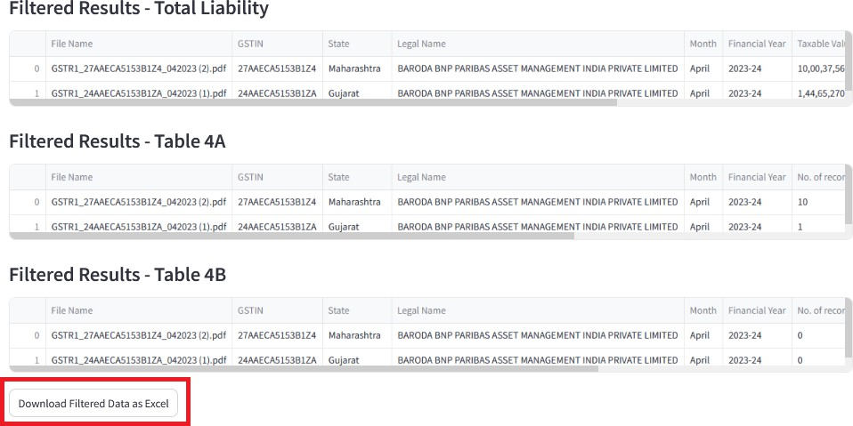

# Process New Files

* + Upload new files at any time to process additional returns
  + The application will append new data to the existing dataset.

# Output Details For GSTR-1

* + **Total Liability Sheet**:
    - File Name, GSTIN, State, Legal Name, Month, Financial Year
    - Taxable Value, IGST, CGST, SGST, Cess

# Table 4A Sheet (B2B Regular):

* + - File Name, GSTIN, State, Legal Name, Month, Financial Year
    - No. of records, Value, Integrated Tax, Central Tax, State/UT Tax, Cess

# Table 4B Sheet (B2B Reverse charge):

* + - File Name, GSTIN, State, Legal Name, Month, Financial Year
    - No. of records, Value, Integrated Tax, Central Tax, State/UT Tax, Cess

# For GSTR-3B

* + **Combined Data Sheet**:
    - Comprehensive view of all extracted data organized by file and section
    - File information, Table 3.1, Table 4, and Table 6.1 data in a structured format

# General Details Sheet:

* + - GSTIN, State, Legal Name, Date, Financial Year, Period

# Table 3.1 Sheet:

* + - Nature of Supplies, Total Taxable Value, Integrated Tax, Central Tax, State/UT Tax, Cess

# Table 4 Sheet:

* + - ITC details categorized by type (Available, Reversed, Net Available, Other Details)
    - Integrated Tax, Central Tax, State/UT Tax, Cess values for each category

# Table 6.1 Sheet:

* + - Description, Total Tax Payable, Tax Paid Through ITC, Tax Paid in Cash, Interest Paid in Cash, Late Fee Paid in Cash

# Tips for Optimal Use

1. **Ensure PDF Quality**: Use official GST portal-generated PDFs for best results
2. **Batch Processing**: Group similar return types for more efficient processing
3. **Filter Strategically**: Apply filters progressively, starting with broader criteria
4. **Regular Downloads**: Download filtered data regularly during analysis to prevent data loss
5. **Check Data Consistency**: Verify extracted data against source PDFs for critical analyses

**Thank you for using the GSTR PDF Extractor Tool!**